Packet Tracer – Build a Connected Factory Solution

Topology

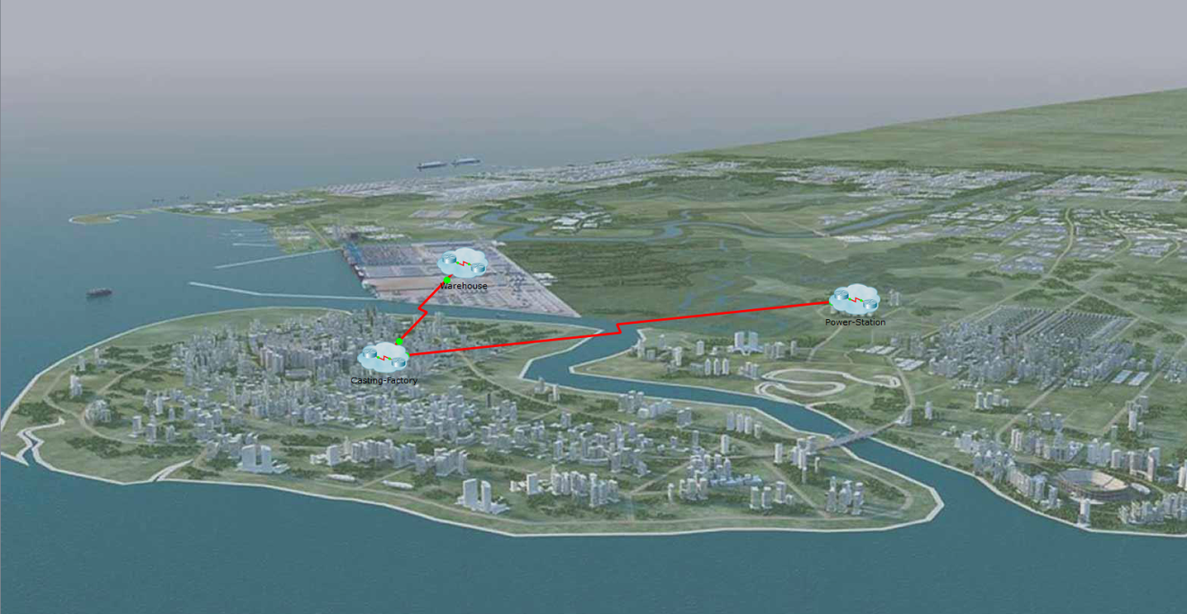

1. Objectives

* **Explore the Connected Factory**
* **Build a Connected Factory Solution of Personal Importance to You**

1. Background / Scenario

In this activity, you will explore the connected factory example. You will then build your own model of a connected factory that incorporates an area of personal interest to you.

1. Explore the Connected Factory
   * 1. Review the Glazing Company Overview page.
        1. Click any PC in the Warehouse and open the **Web Browser** from the **Desktop** tab.
        2. Type **webserver** into the URL box and press **Go**.
        3. Review the company description information.
        4. Once the information has been reviewed, close the PC.
     2. Run the Classic Car

The owner keeps a classic car (the old car in PT) in the warehouse that needs to be run occasionally.

* + - 1. Start the engine by holding the Alt key and clicking the classic car.

How does the warehouse react to having the car running inside of it?

1. Stop the engine.
   * 1. Review the Connected Factory Network Settings.
        1. Click the Factory building to see its layout.
        2. Find the **F-IT-Laptop** and open the **Text Editor** inside the **Desktop** tab.
        3. Use the **File** button to find and open the **IP-Network.txt** file.
        4. Review all the network information about the connections.
        5. Close the Text Editor.
     2. Use browser to monitor factory sensor settings.
        1. Open the web browser on the **F-IT-Laptop** using the **Desktop** tab.
        2. Type **factory** in the URL box and press **Go**.
        3. Use the following table to log into the each area to control the sensors located there.

|  |  |  |
| --- | --- | --- |
| Area | Username | Password |
| Assembly | Assembly | Assembly |
| Preparation | Prep | Prep |
| Power Station | PS | PS |

* + - 1. Review the listed items you can control remotely or with conditions.

1. Build a Connected Factory Solution of Personal Importance to You

Build a connected factory solution of personal importance to you and add it to the Connected Factory.